HTTP Methods Best Practices

Ali-Akbor

**HTTP**

The Hypertext Transfer Protocol (HTTP) is an application-level protocol for distributed, collaborative, hypermedia information systems.

**Basic Architecture**

The following diagram shows a very basic architecture of a web application and depicts where HTTP sits:

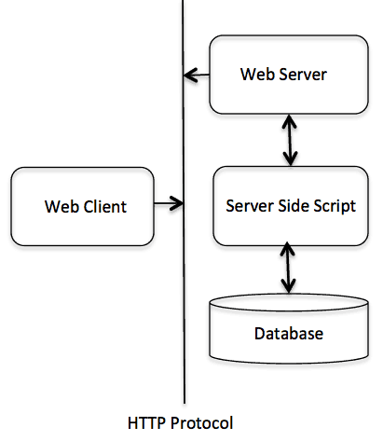

The HTTP protocol is a request/response protocol based on the client/server based architecture where web browsers, robots and search engines, etc. act like HTTP clients, and the Web server acts as a server.

***Client***

The HTTP client sends a request to the server in the form of a request method, URI, and protocol version, followed by a MIME-like message containing request modifiers, client information, and possible body content over a TCP/IP connection.

***Server***

The HTTP server responds with a status line, including the message's protocol version and a success or error code, followed by a MIME-like message containing server information, entity meta information, and possible entity-body content.

**HTTP Methods**

* + [GET](https://assertible.com/blog/7-http-methods-every-web-developer-should-know-and-how-to-test-them#get)
  + [POST](https://assertible.com/blog/7-http-methods-every-web-developer-should-know-and-how-to-test-them#post)
  + [PUT](https://assertible.com/blog/7-http-methods-every-web-developer-should-know-and-how-to-test-them#put)
  + [HEAD](https://assertible.com/blog/7-http-methods-every-web-developer-should-know-and-how-to-test-them#head)
  + [DELETE](https://assertible.com/blog/7-http-methods-every-web-developer-should-know-and-how-to-test-them#delete)
  + [PATCH](https://assertible.com/blog/7-http-methods-every-web-developer-should-know-and-how-to-test-them#patch)
  + [OPTIONS](https://assertible.com/blog/7-http-methods-every-web-developer-should-know-and-how-to-test-them#options)

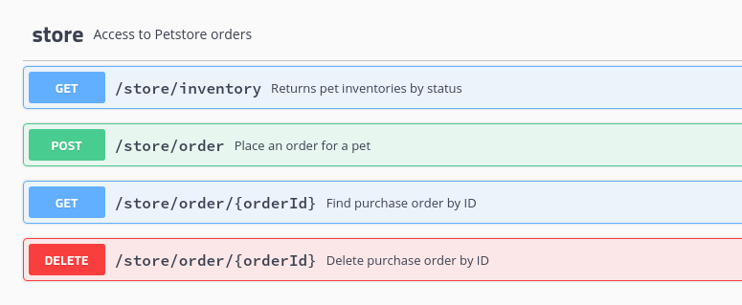

## GET

GET requests are the most common and widely used methods in APIs and websites. Simply put, the GET method is used to **retreive data from a server at the specified resource**. For example, say you have an API with a /users endpoint. Making a GET request to that endpoint should return a list of all available users.

Since a GET request is only requesting data and not modifying any resources, it's considered [a safe and idempotent method](http://restcookbook.com/HTTP%20Methods/idempotency/).

### Testing an API with GET requests

When you're creating tests for an API, the GET method will likely be the most frequent type of request made by consumers of the service, so it's important to **check every known endpoint with a GET request**.

At a basic level, these things should be validated:

* Check that a valid GET request returns a 200 status code.
* Ensure that a GET request to a specific resource returns the correct data. For example, GET /users returns a list of users.

GET is often the **default method in HTTP clients**, so creating tests for these resources should be simple with any tool you choose.

## POST

In web services, POST requests are used to **send data to the API server** to create or update a resource. The data sent to the server is stored in the [request body](https://stackoverflow.com/questions/22034144/what-does-it-mean-http-request-body) of the HTTP request.

The simplest example is [a contact form](https://assertible.com/contact) on a website. When you fill out the inputs in a form and hit Send, that data is put in the **response body** of the request and sent to the server. This may be JSON, XML, or query parameters (there's plenty of other formats, but these are the most common).

It's worth noting that a POST request is **non-idempotent**. It mutates data on the backend server (by creating or updating a resource), as opposed to a GET request which does not change any data. [Here is a great explanation of idempotentcy](https://www.infoq.com/news/2013/04/idempotent).

### Testing an API with POST requests

The second most common HTTP method you'll encounter in your API tests is POST. As [mentioned above](https://assertible.com/blog/7-http-methods-every-web-developer-should-know-and-how-to-test-them#post), POST requests are used to **send data to the API server** and create or update a resource. Since POST requests modify data, it's important to **have API tests for all of your POST methods**.

Here are some tips for testing POST requests:

* Create a resource with a POST request and ensure a 200 status code is returned.
* Next, make a GET request for that resource, and ensure the data was saved correctly.
* Add tests that ensure POST requests **fail** with incorrect or ill-formatted data.

For some more ideas on common API testing scenarios, [check out this post](https://assertible.com/blog/4-common-api-errors-and-how-to-test-them).

## PUT

Simlar to POST, PUT requests are used to send data to the API to **update or create a resource**. The difference is that [**PUT requests are idempotent**](https://developer.mozilla.org/en-US/docs/Web/HTTP/Methods/PUT). That is, calling the same PUT request multiple times **will always produce the same result**. In contrast, calling a POST request repeatedly make have side effects of creating the same resource multiple times.

Generally, when a PUT request creates a resource the server will respond with a 201 (Created), and if the request modifies existing resource the server will return a 200 (OK) or 204 (No Content).

### Testing an API with PUT requests

Testing an APIs PUT methods is very similar to testing POST requests. But now that we know the difference between the two (idempotency), we can **create API tests to confirm this behavior**.

Check for these things when testing PUT requests:

* Repeatedly calling a PUT request always returns the same result ([idempotent](https://assertible.com/blog/7-http-methods-every-web-developer-should-know-and-how-to-test-them#put)).
* The proper status code is returned when creating and updating a resource (eg, 201 or 200/204).
* After updating a resource with a PUT request, a GET request for that resource should return the correct data.
* PUT requests should fail if invalid data is supplied in the request -- **nothing should be updated**.

## PATCH

A PATCH request is one of the lesser-known HTTP methods, but I'm including it this high in the list since it is similar to POST and PUT. The difference with PATCH is that you **only apply partial modifications to the resource**.

The difference between PATCH and PUT, is that a [**PATCH request is non-idempotent**](https://developer.mozilla.org/en-US/docs/Web/HTTP/Methods/PATCH) (like a POST request).

To expand on partial modification, say you're API has a /users/{{userid}} endpoint, and a user has a username. With a PATCH request, **you may only need to send the updated username** in the request body - as opposed to POST and PUT which require the full user entity.

### Testing an API with PATCH requests

Since the PATCH method is so simlar to POST and PUT, many of **the same testing techniques apply.** It's still important to validate the behavior of any API endpoints that accept this method.

What to look for when testing PATCH requests:

* A successful PATCH request should return a 2xx status code.
* PATCH requests should fail if invalid data is supplied in the request -- **nothing should be updated**.

The semantics of PATCH requests will largely depend on the specific API you're testing.

## DELETE

The DELETE method is exactly as it sounds: **delete the resource at the specified URL**. This method is one of the more common in RESTful APIs so it's good to know how it works.

If a new user is created with a POST request to /users, and it can be retrieved with a GET request to /users/{{userid}}, then making a DELETE request to /users/{{userid}} will completely remove that user.

### Testing an API with DELETE requests

DELETE requests should be heavily tested since they generally remove data from a database. Be careful when testing DELETE methods, make sure you're using the correct credentials and not testing with real user data.

A **typical test case for a DELETE request** would look like this:

1. Create a new user with a POST request to /users
2. With the user id returned from the POST, make a DELETE request to /users/{{userid}}
3. A subsequent GET request to /users/{{userid}} should return a 404 not found status code.

In addition, sending a DELETE request to an unknown resource should return [a non-200 status code](https://en.wikipedia.org/wiki/List_of_HTTP_status_codes).

## HEAD

The HEAD method is almost identical to GET, **except without the response body**. In other words, if GET /users returns a list of users, then HEAD /users will make the same request but won't get back the list of users.

HEAD requests are **useful for checking what a GET request will return** before actually making a GET request -- like before downloading a large file or response body. [Learn more about HEAD requests on MDN](https://developer.mozilla.org/en-US/docs/Web/HTTP/Methods/HEAD).

It's worth pointing out that not every endpoint that supports GET will support HEAD - it completely depends on the API you're testing.

### Testing an API with HEAD requests

Making API requests with HEAD methods is actually an effective way of simply **verifying that a resource is available**. It is good practice to have a test for HEAD requests everywhere you have a test for GET requests (as long as the API supports it).

Check these things when testing an API with HEAD requests:

* Verify and check [HTTP headers](https://en.wikipedia.org/wiki/List_of_HTTP_header_fields) returned from a HEAD request
* Make assertions against the status code of HEAD requests
* Test requests with various query parametesr to ensure the API responds

Another useful case for HEAD requests is [API smoke testing](https://blog.codeship.com/add-post-deploy-smoke-tests-to-any-codeship-pipeline/) - **make a HEAD request against every API endpoint** to ensure they're available.

## OPTIONS

Last but not least we have OPTIONS requests. OPTIONS requests are one of my favorites, though not as widely used as the other HTTP methods. In a nutshell, an OPTIONS request should **return data describing what other methods and operations the server supports** at the given URL.

OPTIONS requests are more loosely defined and used than the others, making them a good candidate to **test for fatal API errors**. If an API isn't expecting an OPTIONS request, it's good to put a test case in place that verifies failing behavior.

### Testing an API with OPTIONS requests

Testing an OPTIONS request is dependent on the web service; whether or not it supports that and what is supposed to return will **define how you should test it**.

How to validate an endpoint using OPTIONS:

* Primarily, check the response headers and status code of the request
* Test endpoints that don't support OPTIONS, and ensure they fail appropriately